Natalie Jarusewski and Joshua Pollock

Lab 07 Game Show

31 October 2016

Lab Section 1

**Problem Statement:**

This lab is asking us to create a program that executes a game show for a user. The lab has a few requirements that were necessary to follow. These requirements were:

* A unique theme to our game show
* At least 10 questions
* Each question should not have the same number of possible answers
* The questions need to be given in a random order and none should be repeated
* A main menu function with 3 choices for the user to navigate
* A way so if the user chooses an invalid response the program will wait for them to choose a correct response
* A way to keep track of the users score
* Print the users score after each question

Possible extra credit for the problem is if we come up with a way to store the users high score and make that accessible through the main menu.

**Planning:**

**Implementation and Testing:**

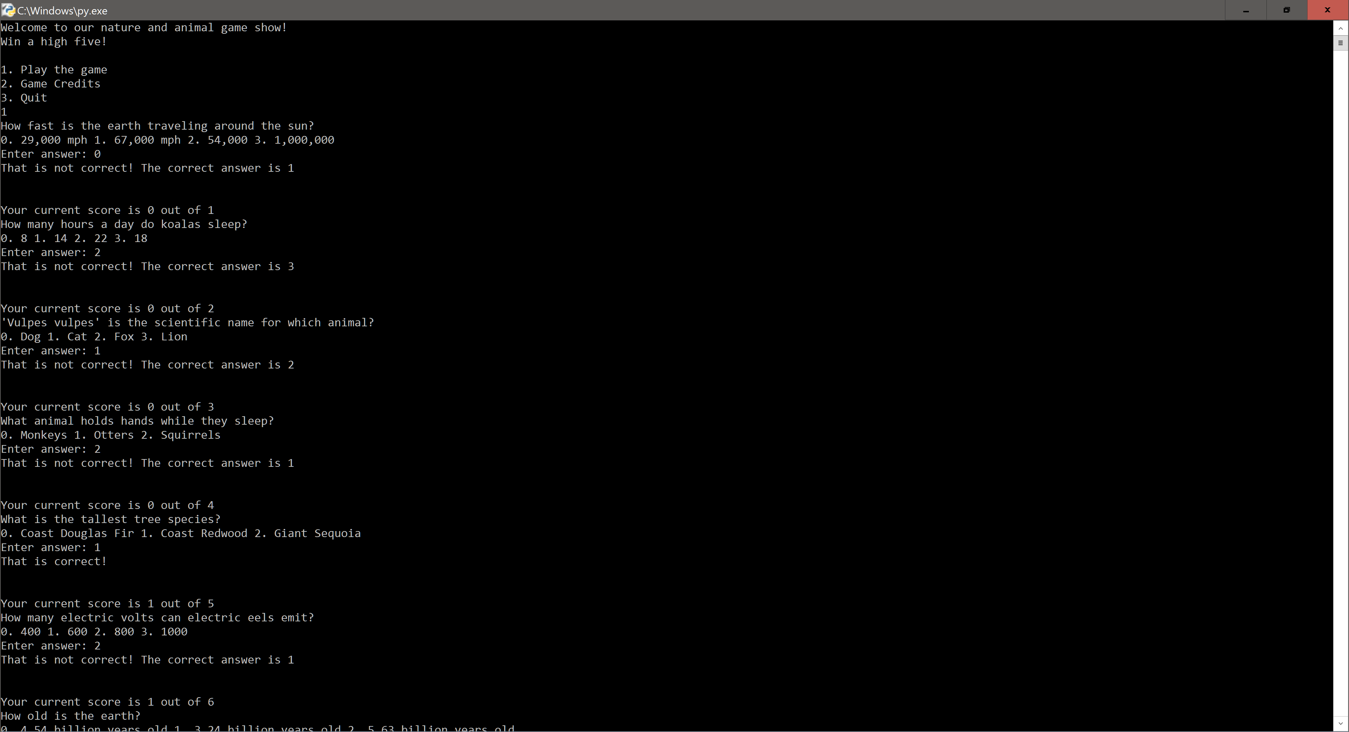

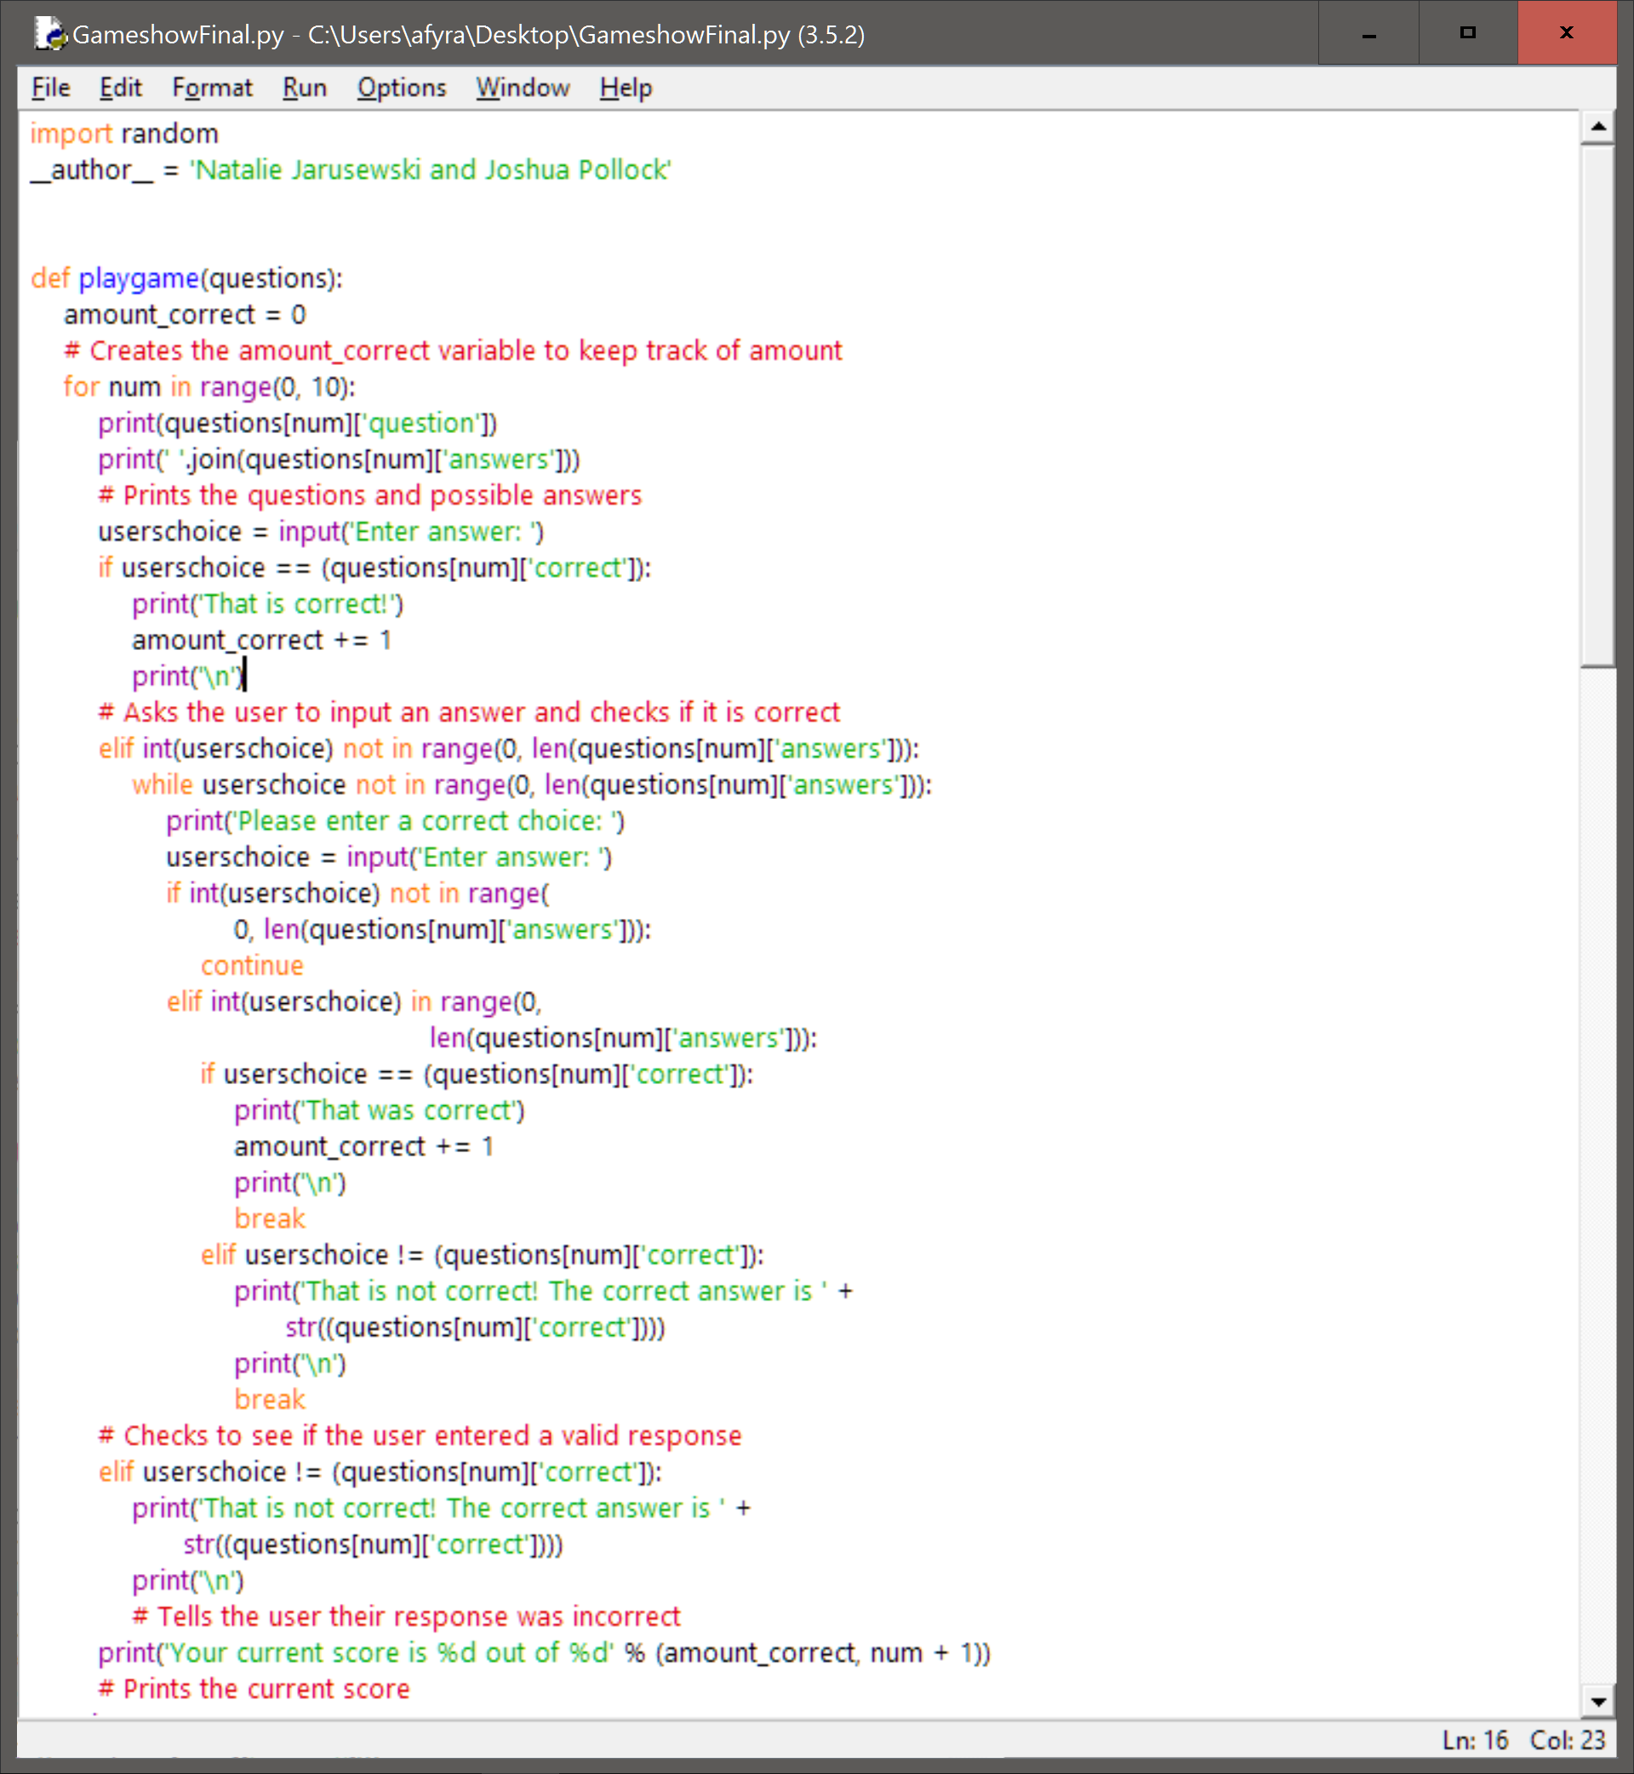

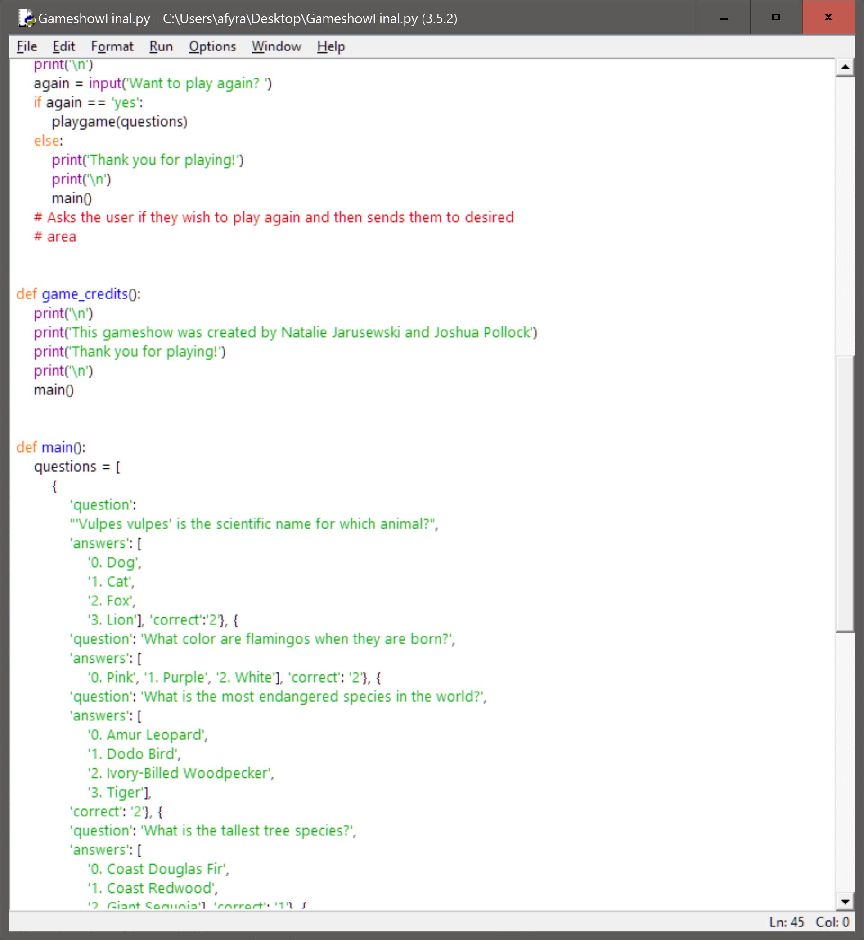

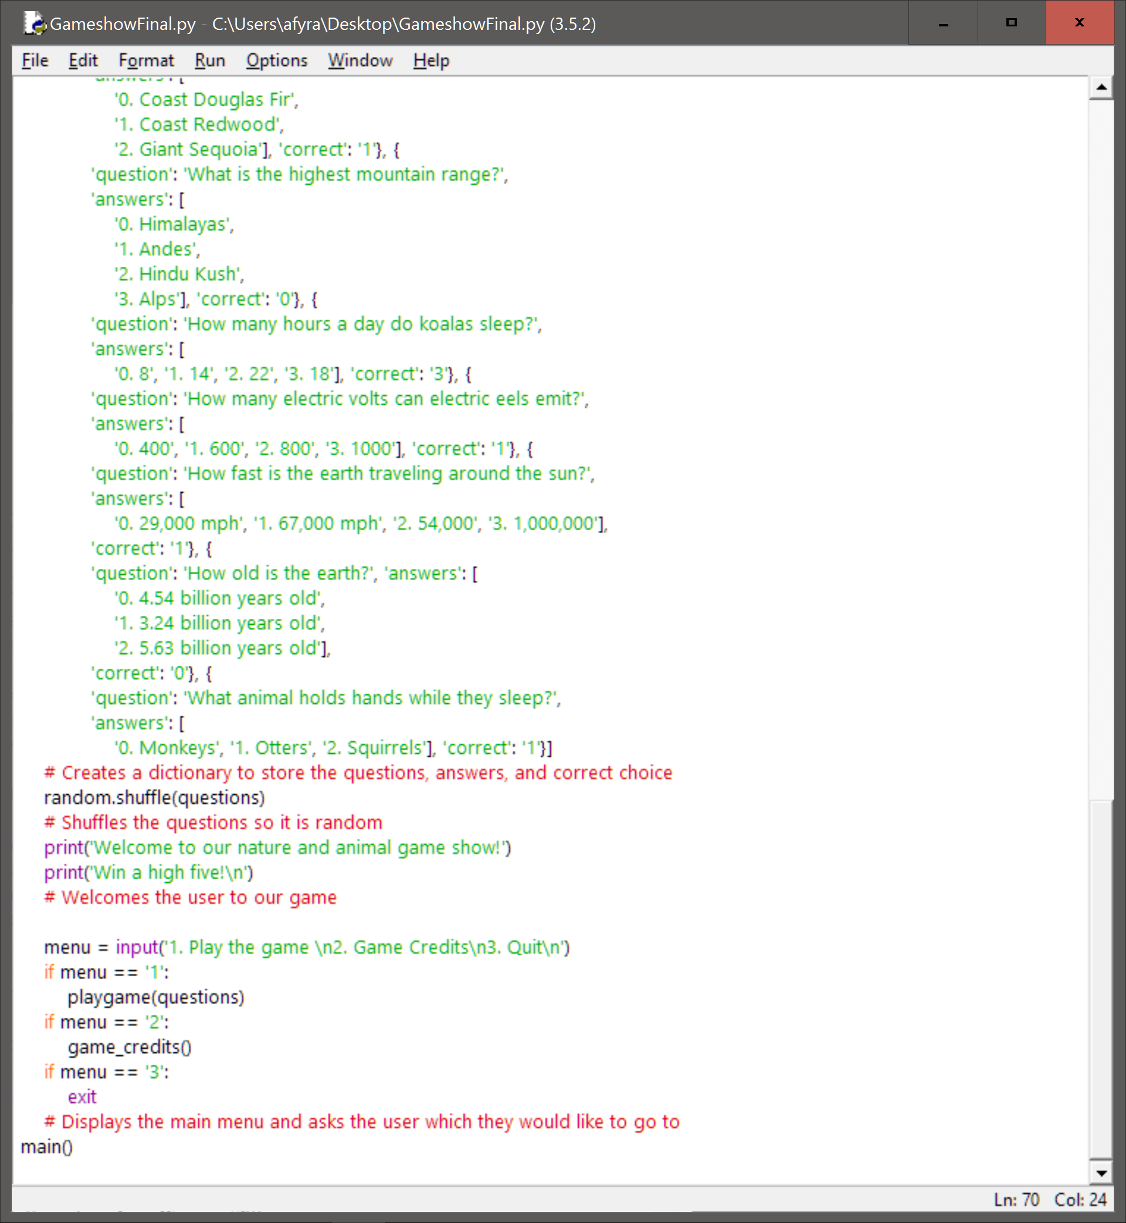

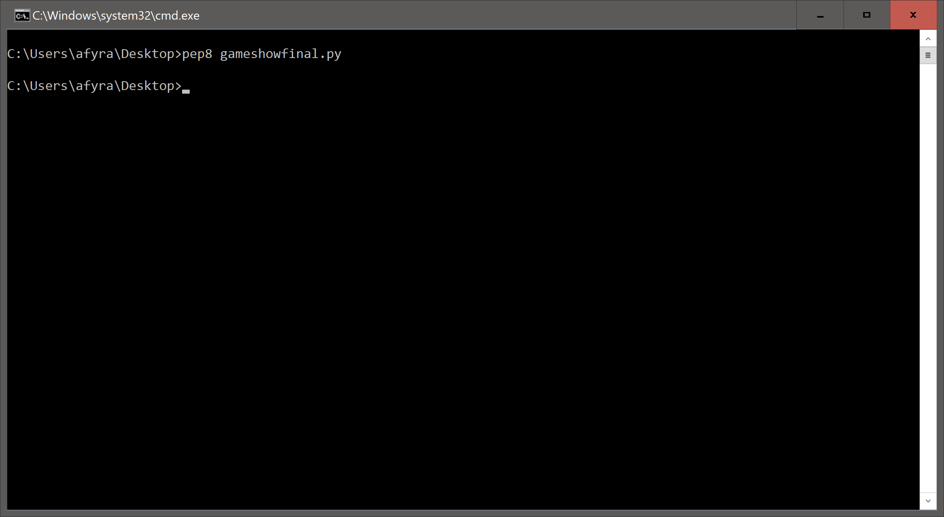

**Reflection and Refactoring:**